Dhaval Patel
M.sc. (CS) Sem-3 Er no: 03220030002034

Q. Create a metamask wallet, add few ether to it and perform financial transactions using
ethereum test network. Observe details of transactions and changes in test blockchain.

- Metamask account created
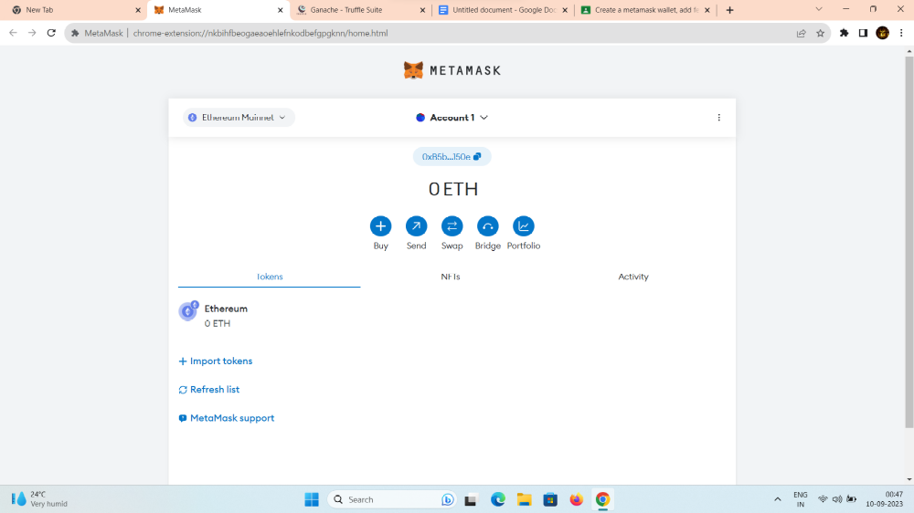
2. For Ethereum test net we will be using “Ganache”
a. https://trufflesuite.com/ganache/
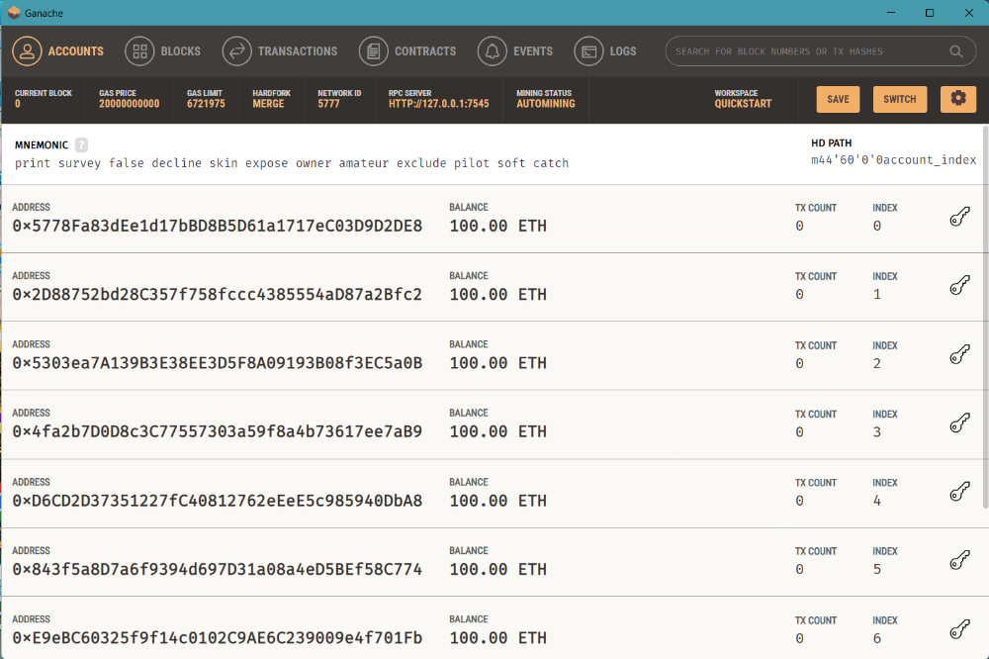
3. Adding ethirum to wallet
